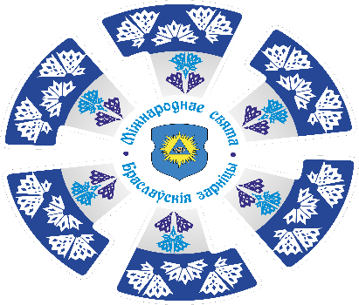
To whom it may concern

Braslav District Executive Committee invite representatives of your region to take part in the International Festival of Traditional Culture «Braslavskiye Zarnitsy» (“Braslav Summer Lightnings”) that will be held 3-4 June, 2023 in Braslav, Vitebsk Region, the Republic of Belarus

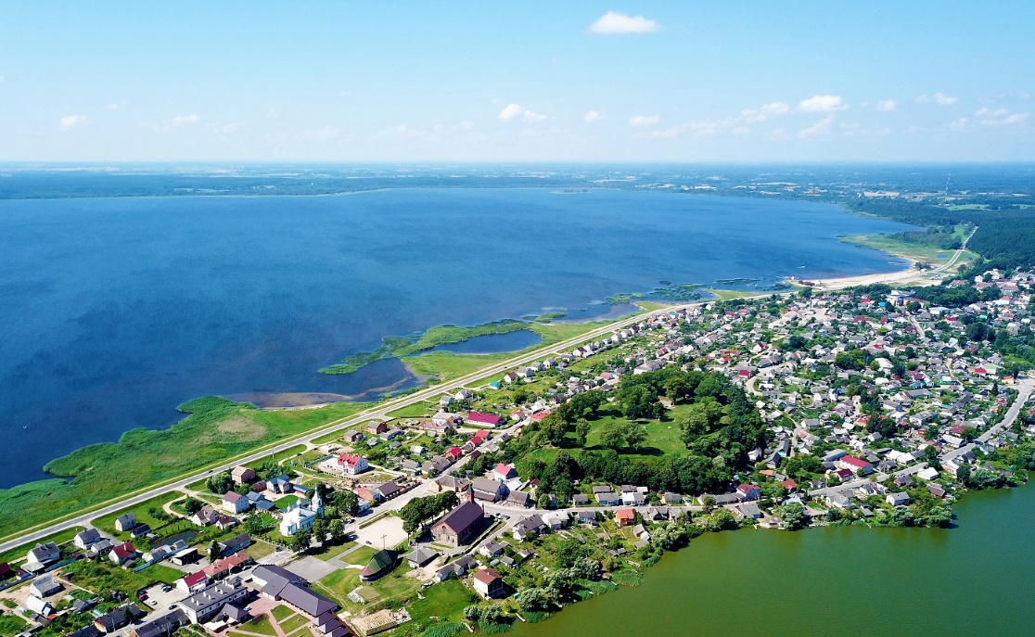

Organizers of the International Festival of Traditional Culture «Braslavskiye Zarnitsy» are:
Ministry of Culture of the Republic of Belarus,
Vitebsk Region Executive Committee,
Braslav District Executive Committee.
The main objectives of the Festival are development and promoting of the participating countries’ traditional culture, strengthening and increasing international cooperation, popularization of culture and tourism of the region.
The symbolic start of the Festival was given by the song contest in 1967. Since 2015, the event has been included in the List of International and Republican Festivals and Holidays that are held in the Republic of Belarus (Decree of the Council of Ministers of the Republic of Belarus No 263 of 02.04.2015). In 2022, the Festival celebrated its 55th anniversary.
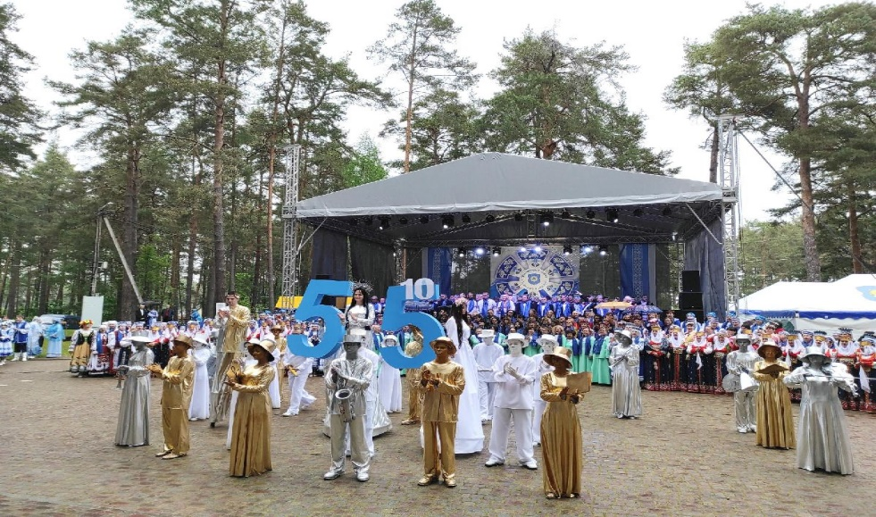
The participants of the Festival are groups of amateur and professional folk art, individual performers, clubs of historic reconstruction, craftsmen from the Republic of Belarus and foreign countries.

Official delegations of the Republic of Belarus and the foreign countries that cooperate with Braslav District or are going to establish new business contacts are welcome to participate.

The programme of the Festival includes an open contest of singing ensembles «Braslav Choir Assembly» (terms of the contest will be sent later),

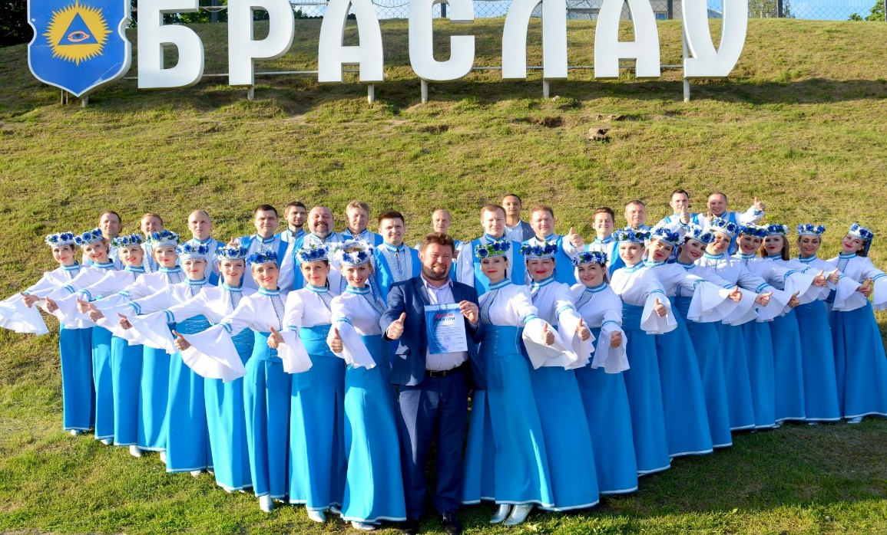

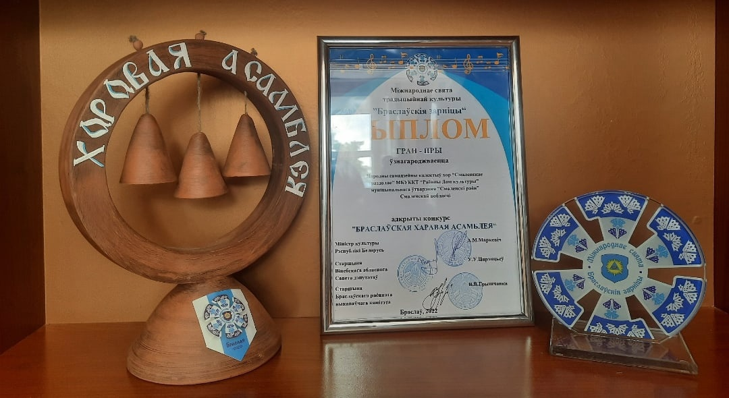

An open regional contest of folk dances «Paazerskiya Tapatki» (terms of the contest will be sent later),
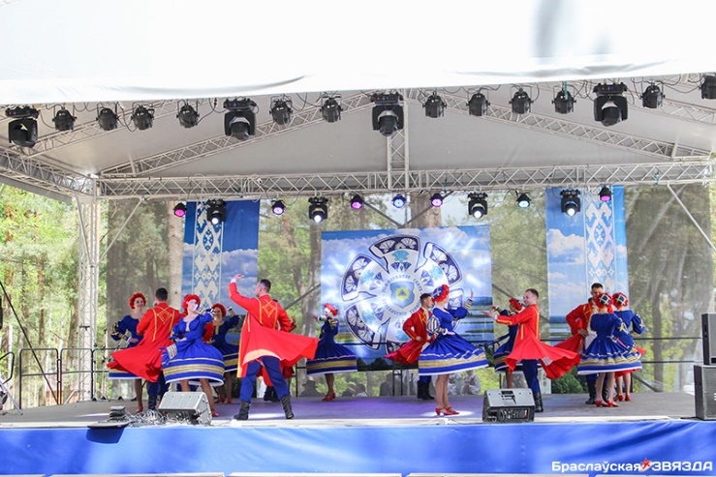

A ceremonial greeting of the Festival with a bright performance of the 1000-people choir and a gala concert.
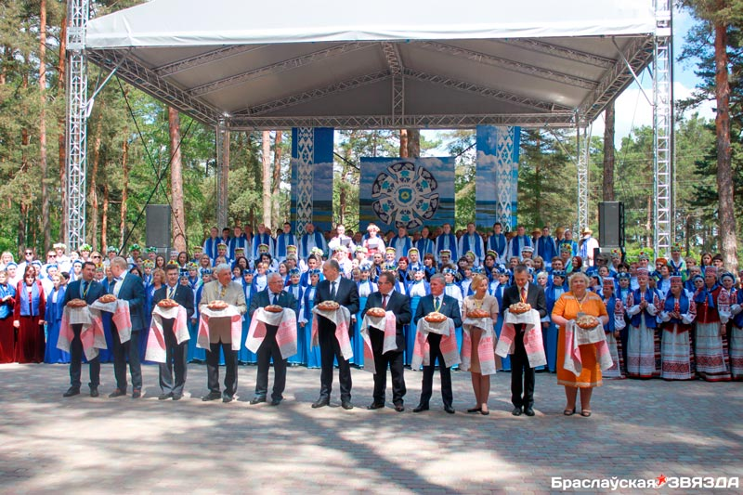

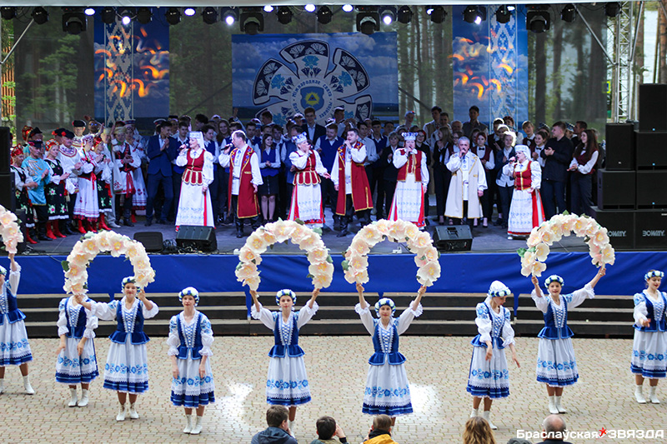

At the same time, a fest of the Medieval Culture “Brachislav’s Sword” takes place in the historic centre of Braslav, a former settlement Zamkavaya Hill that is of cultural and historical value of the Republic of Belarus.

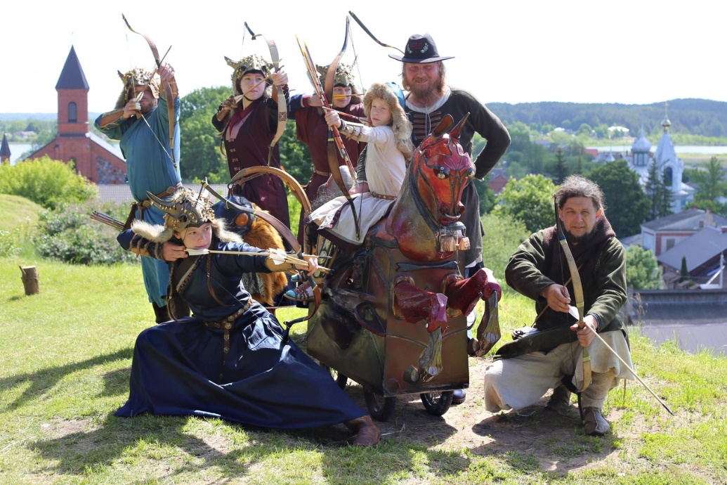

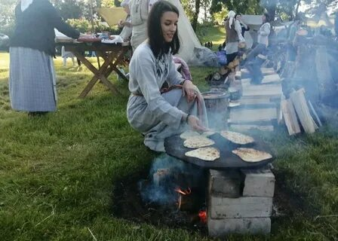
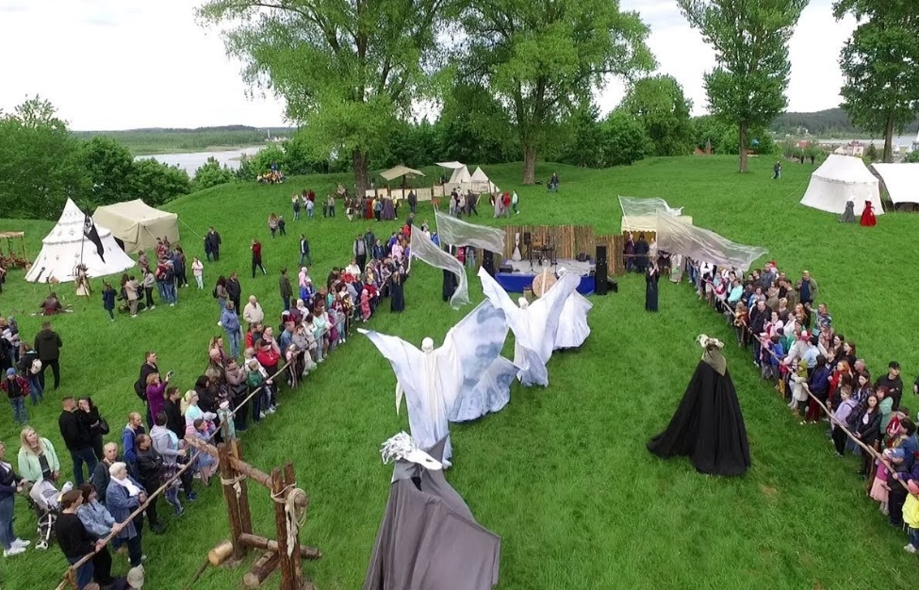

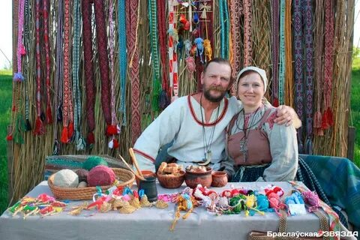
The programme of the Festival includes different exhibitions, workshops, craftwork fairs, concerts of various ensembles (drama, authentic, folk and modern directions, etc.).
Official meetings, presentations, press conferences.
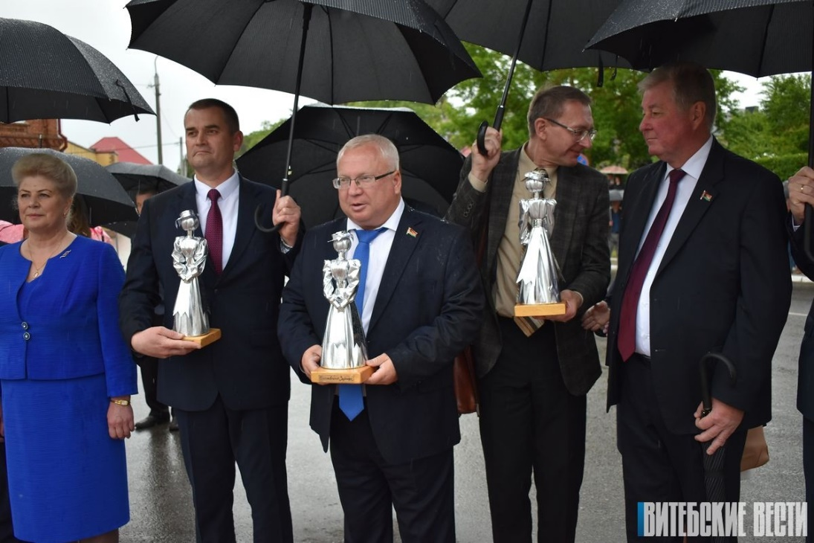
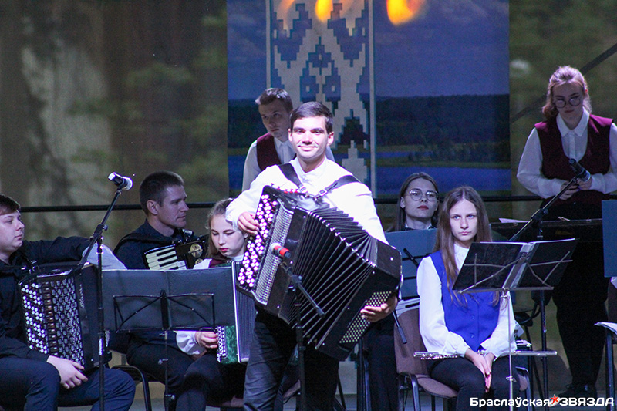

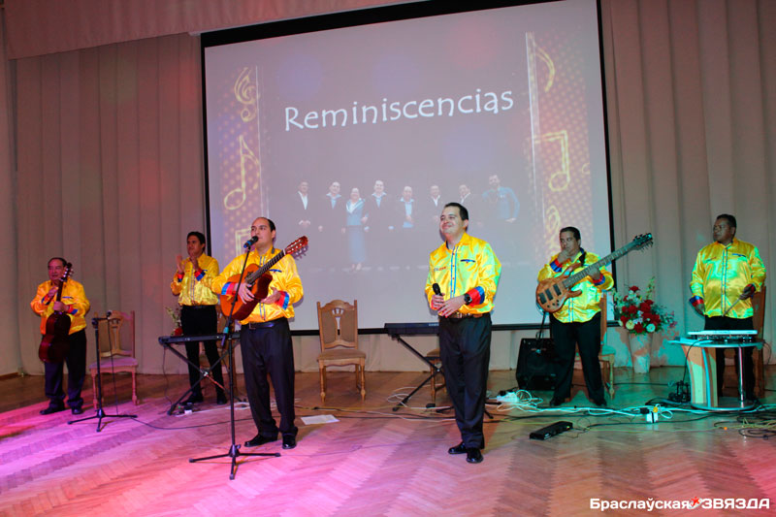

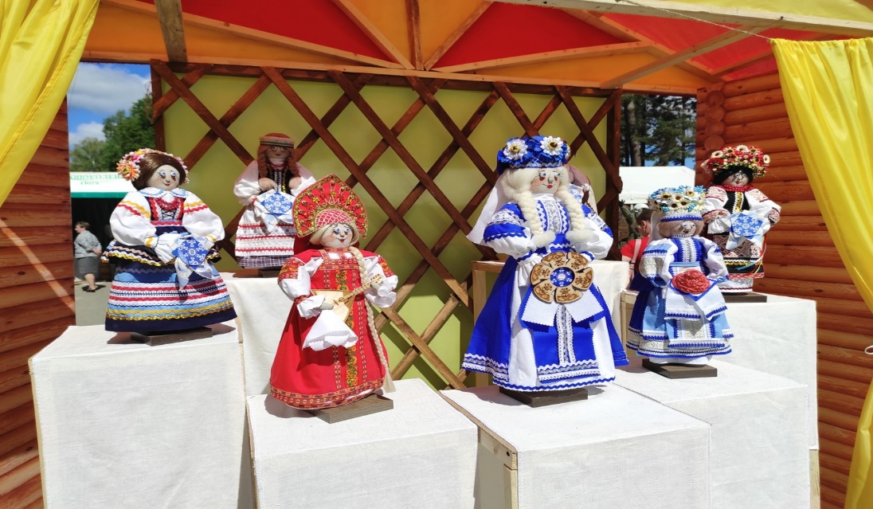
Options for the participation of folk groups, official delegations of a particular region are discussed with the organizers in the process of preparation.
To participate in the Festival, the applicant sends a letter of intent to cooperate with the Braslav District Executive Committee (for official delegations) and (or) the Application Form of the folk group (a sample is attached to this letter) to the email address of the Department of Ideological Work, Culture and Youth Affairs of the Braslav District Executive Committee kultura-braslav@yandex.ru
We are also ready to answer all your questions by phone:
2153 (town code) 68744, +375 29 5909964 (Viber, WhatsApp, Telegram, etc.) or e-mail kultura-braslav@yandex.ru
Contact person: Lyudmila Novikova (Chief Specialist of the Department of Ideological Work, Culture and Youth Affairs of the Braslav Regional Executive Committee).

Important!
Applications for the participation of the folk teams are accepted until February 15, 2023 and are considered by the organizing committee of the Festival within a month from the date of submission. Each incoming application is considered in order to search for new forms and ideas in making up the program.
Confirmation of the participation of the folk team in the Festival is an official letter of invitation from the Braslav District Executive Committee.
The transportation costs of the teams are at the expense of the sending organization, the meals of the participants on the days of the holiday are at the expense of the host.
The provision and payment of accommodation from June 3 to 4 is provided depending on the degree of involvement in the Festival program and the territorial remoteness of the participant from the venue of the event.
Please inform about the possibility of participation of creative representatives of your region in the International Festival of Traditional Culture «Braslavskiye Zarnitsy».
We look forward to collaborating!

QUESTIONNAIRE-APPLICATION
a creative team, a performer, a club of historical reconstruction,
craftsmen and more to participate
in the International Festival of Traditional Culture «Braslavskiye Zarnitsy»,
that will take place June 3-4, 2023 in Braslav, Vitebsk region
Republic of Belarus

Full name of the band, a club (Name Surname of a performer, etc)
Country
City, region
Tel
Email
Website
Team leader (if there is any)
Data for sending a letter of invitation to participate (name of the organization, full name of its head, position, address)
Number of Participants
 | women |  |  | men | total number  to 20 people
Group
Attendants
Drivers
Brief creative characteristic
Technical rider
Microphones, chairs, etc
Photo (Video)
Close-up in electronic form (2-3)

Video with the performance of the band, or a link to the page with the video
Contact information of the organizers
e-mail:kultura-braslav@ yandex.ru
+375 2153 6 87 44
+375 (29)5909964 Lyudmila Novikova (Viber, WhatsApp, Telegram)

